An Exploratory Analysis
Machine and deep learning approaches to predicting influenza deaths
Vishal Patel

Table of Contents
Introduction 3
Background and study aims 3
Related work 3
Dataset description 4
Methodology 4
overview 4
base case parameters 4
Model descriptions 5
baseline measure - persistence 5
linear autoregression 6
feature log transformation 6
support vector regression (svr) 6
lasso non-linear regression 6
regression tree 6
Gradient boosting regression 7
long short term memory (lstm) neural network 7
outcome measures 7
results 7
data exploration 8
base case results – comparison of model results 10
suitability of outcome measures 10
Model comparison 11
senesitivity analysis – impact of varying base case parameters 14
Effect of varying number of prior observations 14
Effect of varying prediction step 18
conclusions and future work 22
discussion of base case results 22
limitations and weaknesses 23
improvements and future work 23
Appendices 25
Packages to import 25
Define input parameters and create train and test datasets 25
Create persistence measure for baseline 26
linear regression 26
linear regression on log transformed inputs 26
svr – linear kernel 27
lasso non-linear regression 27
lstm neural network 28
regression tree 28
gradient boosting regression 28
Bibliography 30

Introduction

Background and study aims
It is estimated by the World Health Organisation (WHO) that seasonal influenza epidemics result in approximately 3-5 million cases of severe illness and between 250,000 to 500,000 deaths every year (World Health Organisation, 2018). In the USA alone, influenza is responsible for the loss of approximately 611,000 life years annually, and is also responsible for significant levels of economic burden in terms of hospitalisations and outpatient GP visits (Molinari NA, 2007). Being a seasonal illness, the bulk of the epidemic is felt in the winter. The timing and severity of the epidemic is particularly difficult to predict as it is dependent on a number of factors such as acquired immunity, natural immunity, as well as the severity and virulence of the circulating viral strain (Osthus D, 2017). Most health authorities have some form of surveillance reporting for influenza, with a common measure being weekly reports of influenza related hospitalisations or deaths. These measures provide an estimate of the severity of the influenza virus for a given season. There is considerable value in using historical trends in these measures to be able to predict the timing and severity of the influenza epidemic for a given season.
The aim of this study is to evaluate potential machine learning and deep learning approaches which may be used to predict the number of weekly influenza attributable deaths in the USA based on the reported number of deaths in previous weeks (i.e. from time series data). The data for this study were obtained from the Centre for Disease Control and Prevention (CDC).

Related work
A study has very recently been published (April 2018) which adopts the approach of a long short term memory (LSTM) neural network to predict seasonal influenza in the USA (Zhang J, 2018). Unlike our study, this study looked at rates of influenza like illness rather than influenza attributable deaths. Influenza like illness is a standard diagnosis for influenza used in many surveillance networks to monitor influenza circulation and is usually diagnosed by general practitioners (GP). As far as I can tell, this is the only recent publication attempting to predict future influenza burden based on prior time series data. Another study published in 2017 adopted a Bayesian methodology to simulate seasonal influenza epidemics based on data collected from GP practices and hospitalization records (Rajaram S, 2017). The objective of this study was to simulate influenza epidemics for the purposes of evaluating the impact of vaccinations, however the study did not attempt to predict future influenza burden based on historical/previous data. Finally, a standard epidemiological technique for modelling infectious diseases known as Susceptible-Exposed-Infected-Recovered (SEIR) modelling has been used to model influenza circulation and epidemics (Baguelin M, 2013). Such models are informed by a combination of clinical and laboratory data and have been shown to be useful for the purposes of estimating the impact of vaccination strategies.

Dataset description
The data for this study was obtained from a publically available influenza and pneumonia surveillance dataset published by the CDC (https://gis.cdc.gov/grasp/fluview/mortality.html). The data reports the number of influenza and pneumonia attributable deaths (both separately and combined) which have occurred in the USA (nationally and by state) per week. The data covers the period from 2009 until 2018 and is reported by season. An influenza season begins on the 40th week of the year, and runs until the 39th week of the following year (the dataset covers nine consecutive influenza seasons, beginning with the 2009-2010 season). Data are reported by three age groups (0-17 year, 18-64 years, and 65+ years), as well as for all age groups combined. The base case analysis in this study focusses on the data for the 65+ age group, as this is the age group in which the vast majority of deaths occur (please see the data exploration section for further details ( page 8)).

Methodology
The sections below detail the methodology for this study.

overview
Figure 1 provides an overview of the analysis for this study. The models take as input a number of prior observations in weekly deaths and predicts the number of deaths after a given number of weeks (prediction step) in the future. Both the number of prior observations and length of the prediction step can be varied within the code I have developed, however have been set as fixed for the base case analysis (see below fort he base case parameters).
Figure 1: Study design overview
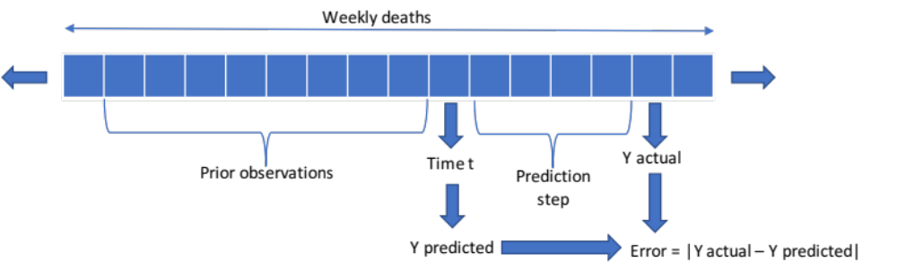

base case parameters
The parameters for the base case analysis are as follows:
- Age group – 65+ year population – this group was selected as they account for the majority of influenza deaths
- Prediction step – 16 weeks (the effect of varying this parameter was explored in the sensitivity analysis)
- Prior observations – 52 weeks (the effect of varying this parameter was explored in the sensitivity analysis)
- Train-test split – A 0.8:0.2 train test split was used on the dataset
The training dataset consists of 237 weeks of usable training data (after the first 52 weeks have been removed as there are not sufficient prior observations for these values), while the test dataset consists of 129 weeks of data. The model specific base case parameters are described in the Model Description section below.

Model descriptions
The sections below provide an overview of each of the models which were compared as part of this study. It should be noted that is likely that each of the models could be improved by further tuning the specific parameters, however as the primary objective of this study is a general comparison of the different types of models, in-depth parameter tuning was not undertaken. Normalising the feature values was also considered, however it was decided not to normalise as part of the base case analysis as the feature vectors are all of the same units (number of weekly deaths), and there are no apparent long term trends which need to be adjusted for. Note that the code for the base case analysis for defining the train and test data and for each of the models evaluated is provided within the Appendix.

baseline measure - persistence
A measure of persistence was used to establish a baseline level of accuracy to compare with the other models. Persistence is a standard measure for baselining in time-series studies, and is based on the principle of using the value at time t-1 as a prediction for value at time t. For this study, given that I am using a prediction step of 16 weeks for the base case analysis, it would be considered appropriate to use a value of y(t-16) as an estimate of y(t) for persistence. However, it was considered that this would have little practical value as the following assumption: y(t) ≈ y(t-16) would be unrealistic for the purposes of predicting influenza deaths during the winter epidemic period. This can be seen visually in the Data Exploration section of this report (page 8). It was therefore decided that a more appropriate benchmark would be to use the number of deaths in the corresponding week from the previous year i.e. y(t) ≈ y(t-52) . It is a reasonable assumption to presume that the number of influenza related deaths in the current week, will be equal to those in the same week from the previous year as there is no long term trend in number of influenza deaths. Note that in practice it is known that this is unlikely to be true due to differences in season-specific factors such as viral strain, acquired immunity, natural immunity as well as climatic differences. It is for this reason that predicting influenza epidemics is so challenging. For illustrative purposes, I also present the results with a persistence measure using the approximation of y(t) ≈ y(t-16).

linear autoregression
Linear autoregression is linear regression used for time series. This type of model takes as input the prior values in the series and fits a linear relationship to predict the next value in the series (in this study the next value is the value in the series after the defined prediction step). The model was fit using the Linear_model module from the scikit learn library.

feature log transformation
In addition to the linear autoregression model on the unadjusted features, a linear regression model was also fitted to a log transformed version of the feature vector as well as on a log transformed version of the dependent variable. In this report only the results of the autoregression on the log transformed feature vector have been presented as these produced the most viable results.

support vector regression (svr)
An SVR model is similar to a support vector machine for classification problems, in which hyerplanes are fitted to maximise the distance or margin between training points. In the case of SVR, the kernel function is used to transform the inputs or feature vector into a high-dimensional space, after which a linear separation can be undertaken. After experimenting with different kernels, a linear kernel was selected for the base case analysis. The model was fitted using the SVR module from the scikit learn library.

lasso non-linear regression
Lasso non-linear/linear regression uses regularization coupled with cross validation to penalize co-efficients and prevent against model over fitting. In this study I used a non-linear regression model using lasso regression and allowed polynomial degrees of between 1 and 3. The model was fit using the LassoCV, make_pipeline, and polynomialfeatures module in the scikit learn library. The parameters used for the lasso cross validation for the base case were as follows:
- Length of path (eps) – 0.0001
- n_alphas – 50
- Maximum iterations - 1000

regression tree
Regression trees are similar to decision trees for classification problems, and are trained by sequentially splitting the predictor or feature values based on a loss minimization function (the default function is mean squared error (MSE)). Splits are ordered in relation to the feature values associated with the lowest MSE. For this study the model was fit using the DecisionTreeRegressor module in the scikit learn library. The default values for the built-in function were used to fit the model.

Gradient boosting regression
Gradient boosting involves improving the accuracy of a weak machine learning algorithm by combining or ‘ensembling’ additional models based on residual or error values of the previous model. Gradient boosting has been shown to be a very effective approach for many machine learning applications. In this study I fit the model using the GradientBoostingRegressor module from the scikit learn library (this utilizes a regression tree to fit the data). The default parameters for the function were used for the base case analysis.

long short term memory (lstm) neural network
LSTM neural networks are a particular type of recurrent neural network (RNN) which enable the model to retain long term memory information to make the next step prediction. LSTM neural networks are particularly useful for time-series data which have a periodicity or seasonal component. The model for this study was developed using the keras API for neural networks. The following parameters were used for the base case analysis:
- Number of layers – 1000
- Loss function – Mean squared error
- Optimizer – Adam
- Number of epochs – 100
- Batch size - 5

outcome measures
The primary outcome for this study is a measure of accuracy of each of the models which were evaluated. Three measures of accuracy were used in the base case analysis:
- Mean absolute error (MAE)
- MSE
- Mean average percentage error (MSE)
Accuracy was assessed on the test dataset, which was defined as the last 20% of the full dataset. In addition, accuracy was also assessed by visually inspecting plots of predicted vs actual weekly deaths. This is important, as the main objective of this predictive analysis is to be able to predict the timing and intensity of the seasonal epidemic, and this may not be completely reflected by the three loss functions listed above.

results
The results of the study are described within the sections below.

data exploration
Figure 2 shows the weekly number of deaths across all seasons within the dataset for the 65 and over age group and all age groups. Two key observations can be seen here. Firstly, it can be seen that almost all deaths attributable to influenza occur in the 65 years and above group. This supports the approach to focus on this age group for this study. Secondly, the significant challenge of predicting the intensity (size) of the seasonal epidemic can be seen, as the size of the peak of the epidemic varies greatly from year to year. The peak of the epidemic can vary from less than 150 deaths within a given week, up to over 1000 deaths, with no apparent inter-season trends. It can be seen that outside of the epidemic periods, the number of influenza attributable deaths remains relatively constant and low. The epidemics in each season show rapid exponential growth and decay, as the infection circulates through the population (growth), and as the population becomes immune (decay).
Figure 2: Number of weekly deaths across all seasons

Figure 3 below shows the number of deaths across all seasons for the 0-17 year and 18-64 year age groups. As these are total numbers, not adjusted for relative population size, it is difficult to interpret the relative severity of influenza infections in these two groups. However, it can be seen that there appears to be alignment in the timing of the peaks for each season (at the inter-seasonal scale – see figures below for an illustration of weekly deaths at a seasonal level).
Figure 3: Number of weekly influenza deaths across all seasons for 0-17 and 18-64 age groups

Figure 4 and Figure 5 show weekly deaths for each age group for the 2014-2015 and 2015-2016 seasons respectively. Looking between the figures, you can see the that the timing of the peaks differs, and indeed the timing of the seasonal epidemic is variable between seasons. There is also some evidence that the epidemic starts in the 0-17 year age group before the 18-64 and 65 and above age groups, which supports the theory that influenza circulates amongst young people before being transmitted to older populations. Datasets subdivided into more (granular) age groups would be required to further explore this hypothesis.
Figure 4: Influenza deaths during 2014-2015 season

Figure 5: Influenza deaths during 2015-2016 season

base case results – comparison of model results

suitability of outcome measures
Table 1 shows the MAE, MSE, and MAPE of each of the models on the test dataset. It can be seen that for certain models there is a low level of concordance between the three error measures. This is particularly the case for SVR, regression tree, and gradient boosting regression (the lasso regression models also had very high values for MAPE, but also had relatively high values for MAE and MSE). These three models have unusually high values for MAPE in comparison to the respective values for MAE and MSE. One potential reason for this is that MAPE as a measure disproportionately penalises errors on smaller values. Given that for the weeks outside of the epidemic period, the number of deaths is very low, models which deviate from these estimates will have high MAPE. As our objective is to predict the timing and size of the seasonal epidemic (predicting influenza deaths outside of the winter epidemic period is secondary), MAPE may not be an appropriate measure for this study. It has been included here as a recently published study which used LSTM to predict influenza-like-illness in the USA reported results in terms of MAPE (rates of influenza-like-illness are many magnitudes higher than rates of influenza deaths, and are therefore less variable and easier to predict, therefore MAPE may be a more appropriate measure for this purpose) (Zhang J, 2018). The best outcome measure for our objective is MSE. MSE disproportionately penalizes predicted values which have a large difference from the actual values. MSE is therefore a good metric for our objective of identifying which models are able to predict the seasonal influenza epidemic peak, as models which either do not predict the size and/or timing of the epidemic accurately will be penalized more those which do. Assessment of the base case analysis will focus on MSE and MAE.
Table 1: MAE, MSE, and MAPE for base case analysis
Model | MAE | MSE | MAPE
Persistence – 52 week lag | 103.36 | 48,421.98 | 107.81%
Persistence – 16 week lag | 135.57 | 53,549.52 | 141.41%
Linear autoregression | 139.85 | 93,807.17 | 145.88%
Log transformed linear regression | 126.85 | 33,760.17 | 132.31%
SVR | 90.09 | 36,406.02 | 13666.63%
Lasso regression – 1st degree polynomial | 100.25 | 34,931.19 | 13,489.58%
Lasso non-linear regression – 2nd degree polynomial | 364.92 | 585,344.23 | 57,142.73%
Lasso non-linear regression – 3rd degree polynomial | 340.44 | 445,166.30 | 51,741.56%
Regression tree | 116.27 | 57,492.36 | 27,452.13%
Gradient boosting regression | 91.31 | 29,373.38 | 23,307.90%
LSTM neural network | 73.80 | 26,324.77 | 77.00%

Model comparison
The seasonal periodicity of influenza deaths can be seen by comparing the results of persistence between the time lag of 52 weeks and 16 weeks. Persistence with a lag of 52 weeks had a MAE and MSE of 103.36 and 48,421.98 respectively, in comparison to a lag of 16 weeks which had MAE and MSE of 135.57 and 53,549.52. This shows that the most accurate persistence measure will have a lag period as a multiple of (approximately) 52 (1 year) weeks. Indeed, there may be an interest in evaluating persistence measures with different lag periods of multiple 52, to evaluate if there are any long term periodic trends in seasonal influenza epidemics, however this would require a much larger dataset in terms of number of influenza seasons.
Comparing the different models to the baseline of persistence with 52 week lag, five of the models showed a significant improvement in accuracy. Of these five models, the LSTM neural network and gradient boosting regression showed the most improvement, with MAE and MSE scores of 26,324.77 and 73.80 for the LSTM and 29,373.38 and 91.31 for gradient boosting regression. The other three models which beat the baseline persistence model were the log transformed linear regression (MAE of 126.85 and MSE of 33,760.17), SVR (MAE of 90.09 and MSE of 36,406.02), and 1st order polynomial lasso regression (MAE of 100.25 and MSE of 34,931.19), although the 1st order lasso regression model is an example of how the MSE and MAE can be misleading in interpreting the accuracy for our objective (see the visual inspection of weekly deaths below). Linear autoregression and the 2nd and 3rd degree polynomial lasso regression models all resulted in worse results than persistence (MAE scores of 139.85, 364.92, 340.44 and MSE values of 93,807.17, 585,344.23, and 445,166.30 respectively).
Figure 6 and Figure 7 show visually the predicted and actual number of deaths for each of the models as well as the 52 week lag persistence measure on the test dataset. In general, visual inspection of the plots shows agreement with the base case MAE and MSE results. The LSTM neural network and gradient boosting regression predicted plots show the highest level of alignment with the plots of actual number of deaths. In both cases, predicting the timing of the epidemic appears to be accurate, however the errors seem to be predominantly caused by the size of the predicted epidemic (the size of the epidemic seems to be underestimated by the LSTM, and overestimated by gradient boosting regression – although this is based on only two full seasons of test data). An important point to note here is the chart for lasso regression with 1st degree polynomial (see Figure 7). The MSE and MAE scores for this model indicated that it outperformed the baseline persistence model, however from the chart of predicted vs actual deaths, it can be seen that model predicts a near constant level of weekly deaths, with no seasonal epidemics. This indicates that relying on MSE and MAE is not always the best indicator of model performance for the objective of this study. Of the other models, linear regression on the log transformed features (Figure 6) appeared to show the closest alignment in terms of epidemic size between predicted and actual deaths, while linear autoregression and regression tree models both predicted the timing of the epidemic relatively well.
Figure 6: Predicted vs actual weekly deaths - Persistence, linear autoregression, log transformed autoregression, regression tree, gradient boosting, and SVR
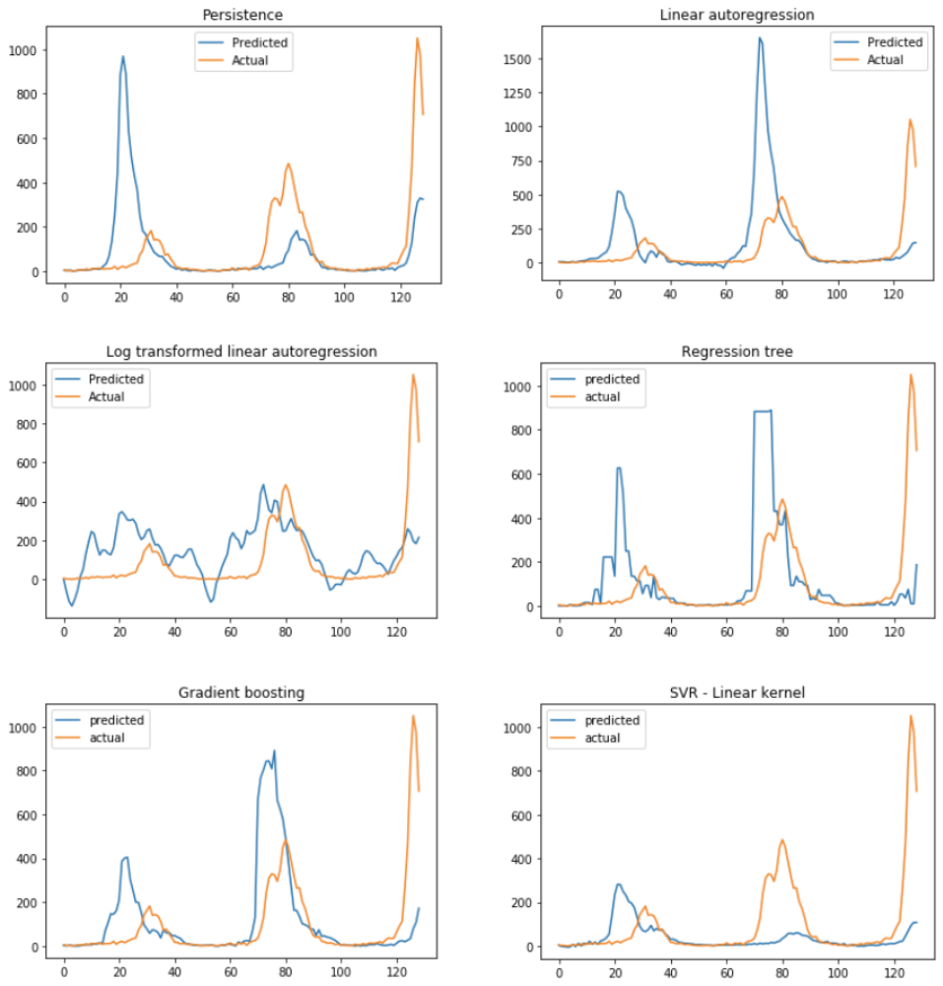

Figure 7: Predicted vs actual weekly deaths - lasso regression and LSTM neural network
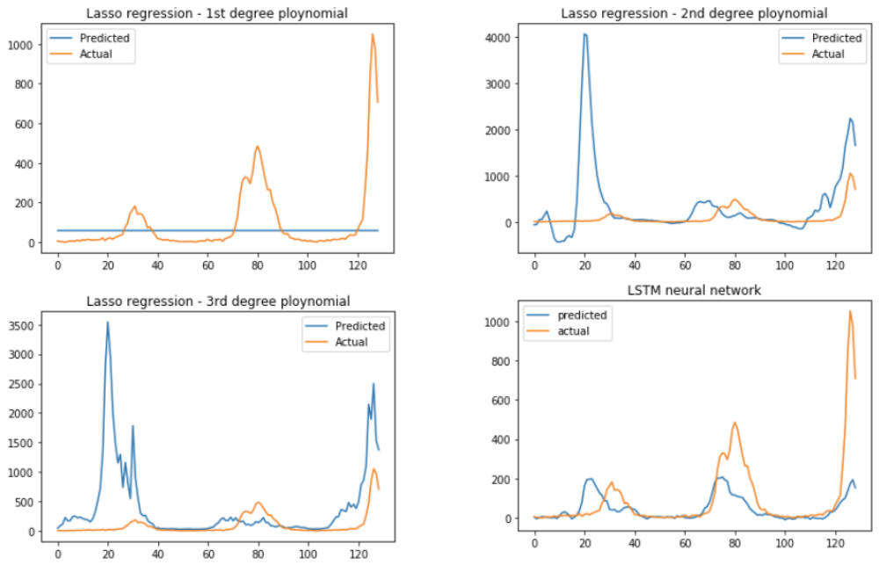

senesitivity analysis – impact of varying base case parameters
In this sensitivity analysis, I tested the effect of varying the number of prior observations (features) and varying the length of the prediction step on the MAE and MSE of each of the models. I also identify the optimal number of prior observations for each model in relation to MAE and MSE scores. It should be noted that in varying the number of prior observations and and length of the prediction step, I am also changing the size of the train and test dataset. For the purposes of this sensitivity analysis, I have only considered the 1st degree polynomial lasso regression model (i.e. linear lasso regression) as the computational time is too great for fitting polynomial models while varying the number of prior observations and predictive step (the linear lasso regression model by far outperformed the two polynomial models in the base case analysis). For similar computational reasons, the number of layers in the LSTM neural network was reduced from 1000 to 500, while the batch size was increased from 5 to 30 (this model was tested on the base case parameters and did not have a significant impact on the MAE and MSE scores – MSE of 26,525.94 vs 26,324.77 for the base case analysis).

Effect of varying number of prior observations
Figure 8 and Figure 9 illustrate the changing MAE and MSE scores for each model as number of prior observations is changed. The overall trends for this are similar between MAE and MSE scores. MAE scores remain relatively stable as you increase the number of prior observations for the linear autoregression, log transformed regression, and SVR models, up until a threshold point after which they begin to increase (this may be due to overfitting). This threshold point appears to be before the number of prior observations used for our base case analysis for the linear regression and log transformed regression models (see Table 1 Table 2 below for the MAE and MSE scores for optimizing the number of prior observations for these two models). This is not completely unexpected as linear regression models can be subject to overfitting as more features are included. For the LSTM neural network, there appears to be a general downward trend in MAE and MSE scores, until a threshold point after which the scores increase. For the lasso regression, regression tree, and gradient boosting regression models, there is a considerable level of variability in the MAE and MSE scores as number of prior observations is changed. There is some evidence of a pattern of periodicity to these variations (in particular for lasso regression), however more data is needed to evaluate this further. Patterns of periodicity may be evidence of other factors being associated with influenza deaths, or may be due to previous epidemics being captured within the prior observations. There is some evidence of a downward trend in this periodic patterns. If these trend is true, it supports an approach of training these models with a large historical dataset. However, the dataset I am currently working with is not extensive enough to be able to dismiss the notion that these are spurious observations. It should also be noted here that the changes in MAE and MSE scores may also be affected by the changing sizes of the train and test datasets as the number of prior observations is changed.
Figure 8: MAE scores vs number of prior observations*
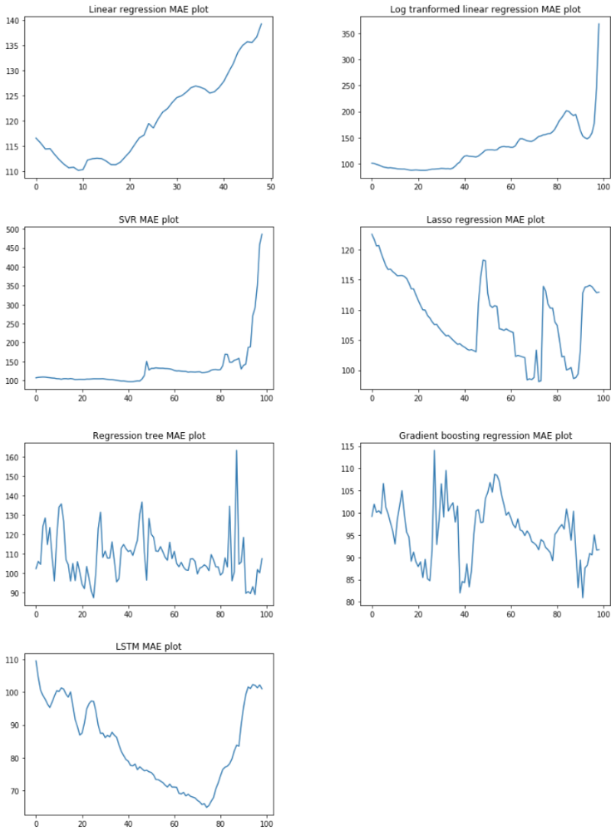
*A 500 layer LSTM neural network with batch size of 30 was used to produce this plot (compared with 1000 layers and batch size of 5 for the base case analysis) – this change was made for computational reasons
Figure 9: MSE scores vs number of prior observations*
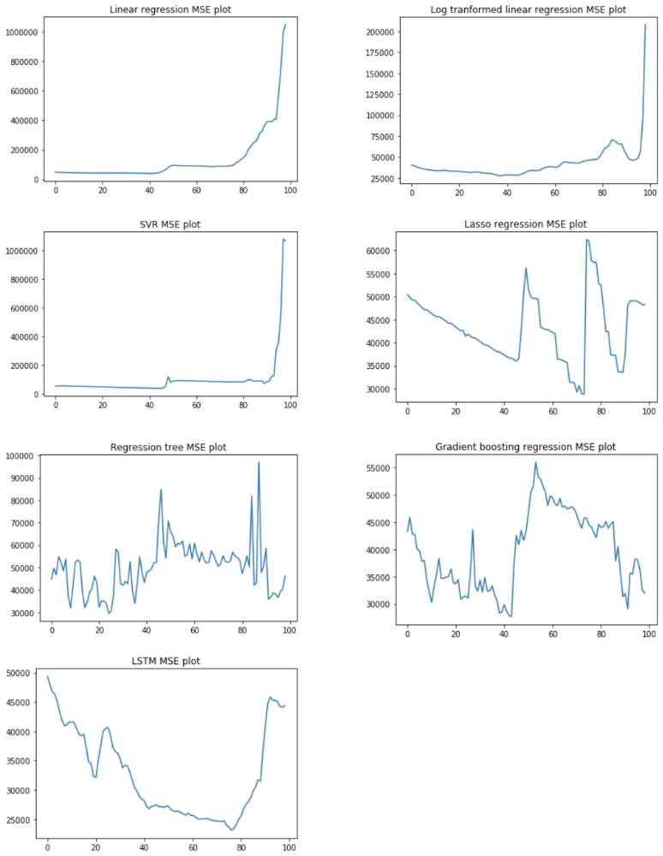
*A 500 layer LSTM neural network with batch size of 30 was used to produce this plot (compared with 1000 layers and batch size of 5 for the base case analysis) – this change was made for computational reasons
Table 2 and Table 3 show the optimal number of prior observations for MAE and MSE for each model respectively, along with the associated MAE and MSE score. All models except for gradient boosting and lasso regression indicated that the optimal number of prior observations was less than that used in the base case analysis (52 weeks). MAE for the linear autoregression model was optimized when using only 10 weeks of prior observations, with the MAE score reducing from 139.85 to 110.15. The log transformed regression model showed an even greater reduction, with MAE reducing from 126.85 to 87.49 when using 24 weeks of prior observations in the model. The regression tree model also demonstrated a significant reduction in MAE, reducing from 116.27 to 87.25 when using the optimal number of prior observations of 26 weeks (however as stated previously, the validity of this outcome is questionable given the high level of variability in the accuracy scores across the range of number of prior observations for the regression tree model).
Table 2: Optimisation of number of prior observations on MAE
Model | Optimal number of prior observations | MAE
Linear autoregression | 10 | 110.15
Log transformed regression | 24 | 87.49
SVR | 42 | 96.69
Lasso regression¹ | 73 | 98.12
Regression tree | 26 | 87.25
Gradient boosting regression | 92 | 80.92
LSTM neural network² | 75 | 64.80
¹Only 1st degree polynomial i.e. linear lasso regression was evaluated here; ²Based on a 500 layer LSTM network with batch size 30

As for the optimization of MAE values, optimal MSE values for each model were produced by using fewer prior observations than were used in our base case for all models except for lasso regression. However, the only significant improvements in MSE scores were for linear autoregression (reduction from 93,807.17 to 39,397.34) and the regression tree model (reduction from 57,492.36 to 29,589.90). As for the MAE scores, the same caveat applies to the optimization of the regression tree score, given the variability associated with changing the number of prior observations.
Table 3: Optimisation of number of prior observations on MSE
Model | Optimal number of prior observations | MSE
Linear autoregression | 42 | 39,397.34
Log transformed regression | 38 | 27,514.26
SVR | 45 | 37,708.57
Lasso regression¹ | 73 | 28,831.70
Regression tree | 25 | 29,589.90
Gradient boosting regression | 44 | 27,657.66
LSTM neural network² | 77 | 23,121.78
¹Only 1st degree polynomial i.e. linear lasso regression was evaluated here; ²Based on a 500 layer LSTM network with batch size 30

Effect of varying prediction step
Figure 10 and Figure 11 illustrate the change in MAE and MSE respectively for each model as the prediction step is varied. Table 4 and Table 5 lists the MAE and MSE scores for each model as the prediction step is increased at five week intervals. As we would expect, all of the models demonstrate better performance in terms of MAE and MSE with a lower prediction window. There is a steep increase in MAE and MSE for all models as the prediction window is increased from one to 10 weeks. Following this, there is some variation between models. For the case of MSE, following the initial increase there is relative stability in scores for linear autoregression, log transformed regression, SVR, lasso regression, and LSTM neural network before another steep increase when the prediction step extends beyond 45 weeks (a similar but less distinct trend is seen for regression tree and gradient boosting). This indicates that the steep increases are due to the prediction steps overlapping with the epidemic period of the influenza season (the second increase is due to the prediction step overlapping with the epidemic period of the following season). This is what we would expect given that it is likely that the MSE score in particular is driven by the errors during the epidemic period.
Figure 10: Varying predictive window length - MAE plots
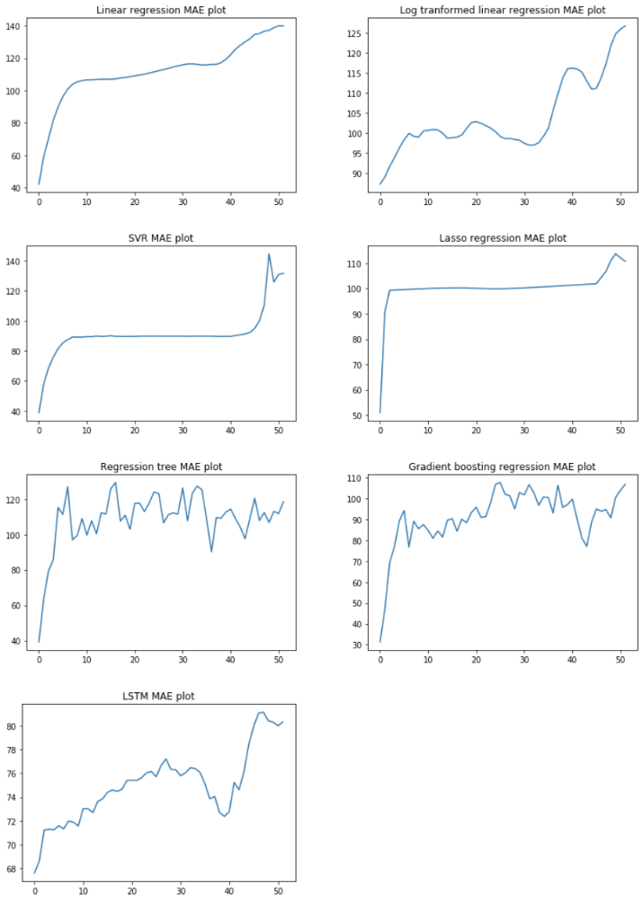

Figure 11: Varying predictive window length - MSE plots
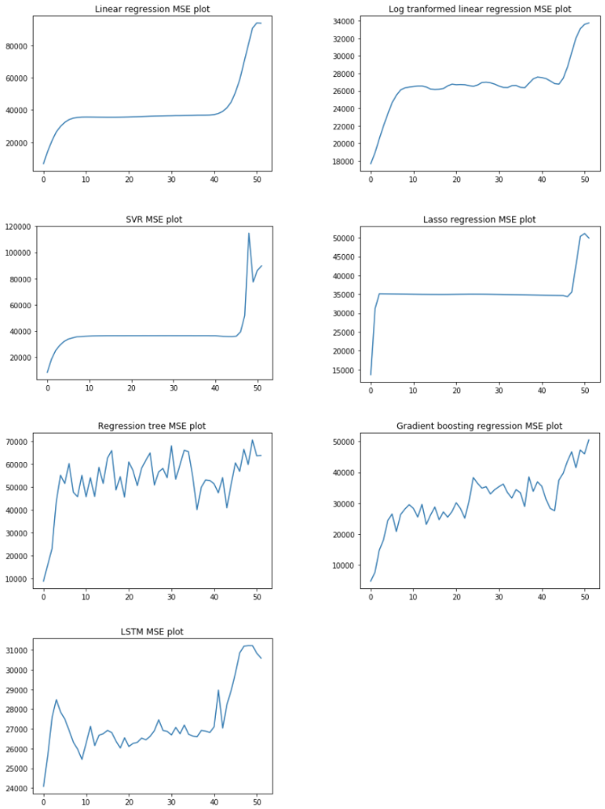

Table 4: MAE score for varying predictive window length
Predictive window | Linear autoregression | Log transformed regression | SVR | Lasso regression | Regression tree | Gradient boosting regression | LSTM neural network
1 | 42.17 | 87.31 | 38.87 | 51.03 | 39.38 | 31.36 | 67.59
5 | 89.75 | 96.37 | 81.56 | 99.49 | 115.23 | 89.28 | 71.23
10 | 106.09 | 100.59 | 89.20 | 99.92 | 108.95 | 87.53 | 71.56
15 | 107.00 | 98.76 | 89.76 | 100.22 | 111.58 | 89.58 | 73.85
20 | 108.55 | 102.70 | 89.69 | 100.16 | 102.94 | 93.29 | 75.41
25 | 111.44 | 100.37 | 89.87 | 99.92 | 123.98 | 106.79 | 76.15
30 | 115.23 | 98.26 | 89.82 | 100.18 | 111.43 | 102.88 | 76.29
35 | 115.69 | 99.29 | 89.84 | 100.67 | 125.19 | 100.76 | 76.06
40 | 119.29 | 116.14 | 89.66 | 101.22 | 112.60 | 97.11 | 72.37
45 | 131.89 | 111.03 | 92.23 | 101.79 | 108.99 | 88.66 | 78.44
50 | 138.71 | 124.83 | 125.90 | 113.72 | 113.02 | 100.51 | 80.32

Table 5: MSE score for varying predictive window length
Predictive window | Linear autoregression | Log transformed regression | SVR | Lasso regression | Regression tree | Gradient boosting regression | LSTM neural network
1 | 6,641.18 | 17,681.79 | 8375.13 | 13,642.26 | 8,685.35 | 4,717.47 | 24,084.34
5 | 29,755.51 | 23,392.67 | 31,986.88 | 35,078.85 | 55,204.98 | 24,379.18 | 27,850.80
10 | 35,508.12 | 26,431.19 | 35,950.86 | 34,994.60 | 55,166.14 | 29,523.67 | 25,450.38
15 | 35,461.20 | 26,197.55 | 36,402.56 | 34,936.03 | 51,598.05 | 26,174.57 | 26,755.73
20 | 35,522.48 | 26,767.98 | 36,425.35 | 34,947.88 | 45,570.84 | 27,256.80 | 26,548.77
25 | 35,944.36 | 26,525.53 | 36,434.07 | 34,993.75 | 61,744.60 | 38,296.98 | 26,442.69
30 | 36,364.69 | 26,765.01 | 36,451.80 | 34,944.10 | 54,094.31 | 34,381.99 | 26,869.59
35 | 36,568.07 | 26,610.27 | 36,440.14 | 34,851.64 | 65,548.60 | 34,402.36 | 26,728.89
40 | 36,805.86 | 27,582.91 | 36,381.39 | 34,752.55 | 52,908.60 | 36,912.91 | 26,816.76
45 | 44,828.12 | 26,766.91 | 35,629.62 | 34,653.80 | 51,192.08 | 37,459.08 | 28,954.92
50 | 90,638.49 | 33,104.92 | 77,345.22 | 50,329.68 | 70,706.79 | 47,241.08 | 31,215.34

conclusions and future work

discussion of base case results
The base case prediction step parameter of 16 weeks was deliberately designed to be ambitious, given the known difficulty of predicting the characteristics of seasonal influenza epidemics. This was evidenced by the sensitivity analysis in the results evaluating model performance which showed MAE and MSE increasing as the prediction step is increased. However even given this challenge, a number of the machine learning algorithms performed very well in comparison to the baseline persistence measure (52-week lag). In particular, the LSTM neural network and gradient boosting regression models showed very promising results. The success of the LSTM neural network in this application is somewhat expected, given the success of this type of network on sequential and time-series data, however it was valuable to see how it performed with influenza data. Gradient boosting regression is not an approach that has routinely been used to model sequential data, but there may be some value in these ensembling techniques to fit data which have some form of seasonality or sequence patterns. The results of this study do not support the use of polynomial lasso regression or SVR for modelling seasonal infectious diseases, however further evidence on different datasets may bring more success.

limitations and weaknesses
The main weakness of this study is inconsistency and size of the dataset. The CDC dataset relies on a cause of death of influenza being reported on death certificates, and it is known that this is not always reliably recorded. It is likely that there is under reporting of influenza deaths, and the level of under reporting may differ between states and sites. There is therefore a need to replicate this work on a more robust and larger dataset. There would also be value in reproducing this work on a dataset with a broader set of outcome metrics (such as influenza related hospitalisations).
Another weakness in the study are the outcome measures used to assess model performance. It was seen in the base case results for lasso regression with 1st degree polynomial (see Figure 7) that MAE and MSE may not be valid measures for model performance in predicting influenza epidemics. While I also utilized a visual inspection of predicted vs. actual weekly death plots for each model, there is a need for a more formal evaluation of model performance in this regard (see Improvements and Future Work below).
It should also be noted that this study did not include a comprehensive evaluation of each model in terms of hyper parameters. It is likely that the performance of each model can be improved by tuning these parameters, however this went beyond the scope of this study (one example of this is that the linear autoregression model performs much better with a smaller number of prior observations). Of particular interest here would be the architecture of the LSTM neural network (it would be of interest to see how model performance changes with different optimization and activation functions).

improvements and future work
In relation to evaluating model performance, there would be some value in devising a metric which places additional weight on errors occurring during an epidemic period. An influenza specific measure in this case may not be difficult to develop. This type of measure could also be very useful if it could be incorporated into training a neural network.
Another improvement to this study would be to incorporate a broader range of features. Currently we rely on the previous observations of weekly deaths to train the model, however there may be value in utilizing other features such as weekly mean temperature, viral strain, and even the number of deaths/influenza cases in other countries.
Finally, these models would almost certainly be improved with a longer dataset. The existing CDC dataset covers the period from the 2009-10 influenza season up until the 2017-2018 season (only partially covered). Datasets with more historic data would lead to better informed models with more accurate predictions.

Appendices
The sections below detail the code used for the base case analysis. Code for the sensitivity analysis has been included as an ipython book with this submission (the base case analysis code has been enclosed also).

Packages to import
- import pandas as pd
- import numpy as np
- import math
- from keras.models import Sequential
- from keras.layers import Dense
- from keras.layers import LSTM
- import matplotlib.pyplot as plt
- from sklearn import linear_model
- from sklearn.metrics import mean_absolute_error
- from sklearn.metrics import mean_squared_error
- from sklearn.svm import SVR
- from sklearn.preprocessing import MinMaxScaler
- from sklearn.preprocessing import PolynomialFeatures
- from sklearn.linear_model import LassoCV
- from sklearn.pipeline import make_pipeline
- from scipy.stats import pearsonr
- from sklearn import tree
- from sklearn import ensemble

Define input parameters and create train and test datasets
- Data = pd.read_csv("/Volumes/Toshiba/DataScienceMasters/Deaths_from_pnuemonia_and_influneza_and_all_deaths__by_state_and_region__National_Center_For_Health_Statistics_Mortality_Surveillance_System.csv")
- nationalData = Data.loc[Data['geoid']=='National']
- scaler = MinMaxScaler(feature_range=(0,1))
- ageGroup = '65 years and older' #Which age group do we want to predict
- pAgeGroup = '65 years and older' #which age group do we want to use to make our predictions
- predictiveWindow = 16 #how many weeks into the future do we want to be able to predict
- pObs = 52 #number of prior observations to use for prediction
- trainTestSplit = 0.8 #Proportion of dataset to be used for training
- outcome = 'Deaths from influenza' #which outcome to model
- Data1 = nationalData.loc[nationalData['age']== ageGroup]
- Data2 = np.asarray(Data1[[outcome]]) #Dataset containing our train and test predictions
- Data3 = nationalData.loc[nationalData['age']==pAgeGroup]
- Data4 = np.asarray(Data3[[outcome]]) #Dataset containing our our independent variables

- xTrain = []
- yTrain = []
- for i in range(pObs, int((len(Data2)-pObs)*trainTestSplit-predictiveWindow)):
- yTrain.append(Data2[i+predictiveWindow])
- xTrain.append(Data4[i-pObs:i].ravel())

- xTest = []
- yTest = []
- for i in range(int((len(Data2)-pObs)*trainTestSplit-predictiveWindow), len(Data2)-predictiveWindow):
- yTest.append(Data2[i+predictiveWindow])
- xTest.append(Data4[i-pObs:i].ravel())

Create persistence measure for baseline
- persistencePredictiveWindow = 52 #how many weeks into the future do we want to be able to predict
- pObs = 52 #number of prior observations to use for prediction
- trainTestSplit = 0.8 #Proportion of dataset to be used for training
- outcome = 'Deaths from influenza' #which outcome to model
- Data1 = nationalData.loc[nationalData['age']== ageGroup]
- Data2 = np.asarray(Data1[[outcome]]) #Dataset containing our train and test predictions

- x = []
- y = []
- for i in range(int((len(Data2)-pObs)*trainTestSplit), len(Data2)):
- x.append(Data2[i-persistencePredictiveWindow])
- y.append(Data2[i])

- persistenceMAE = mean_squared_error(x, y)
- print(persistenceMAE)
- print(mean_absolute_error(x,y))
- print(np.sum(np.abs(np.asarray(x)-np.asarray(y)))/sum(np.asarray(y)))

- plt.clf()
- plt.plot(x, label='Predicted')
- plt.plot(y, label = 'Actual')
- plt.legend()
- plt.title('Persistence')
- plt.show()

linear regression
- lm = linear_model.LinearRegression()
- model = lm.fit(xTrain, yTrain)
- yPredlm = model.predict(xTest)
- lmMAE = mean_squared_error(yTest, yPredlm)
- print(lmMAE)
- print(mean_absolute_error(yTest, yPredlm))
- print(sum(abs(np.asarray(yPredlm)-np.asarray(yTest)))/sum(np.asarray(yTest)))
- plt.clf()
- plt.plot(yPredlm, label = 'Predicted')
- plt.plot(yTest, label = 'Actual')
- plt.legend()
- plt.title('Linear autoregression')
- plt.show()

linear regression on log transformed inputs
- lmxTrain = np.log(np.asarray(xTrain)+1)

- lmxTest = np.log(np.asarray(xTest)+1)

- lm = linear_model.LinearRegression()
- logmodel = lm.fit(lmxTrain, yTrain)
- logyPred = logmodel.predict(lmxTest)
- MAE = mean_absolute_error(yTest, logyPred)
- MSE = mean_squared_error(yTest, logyPred)
- MAPE = sum(abs(np.asarray(logyPred)-np.asarray(yTest)))/sum(np.asarray(yTest))
- plt.clf()
- plt.plot(logyPred, label = 'Predicted')
- plt.plot(yTest, label = 'Actual')
- plt.legend()
- plt.title('Log transformed linear autoregression')
- plt.show()

svr – linear kernel
- xTrain = np.asarray(xTrain)
- yTrain = np.asarray(yTrain)
- xTest = np.asarray(xTest)
- yTest = np.asarray(yTest)
- svr = SVR(kernel='linear')
- model1 = svr.fit(xTrain, yTrain)
- yPredSVR = model1.predict(xTest)
- svrMAE = mean_squared_error(yTest, yPredSVR)
- print(svrMAE)
- print(mean_absolute_error(yTest, yPredSVR))
- print(np.sum(np.abs(yPredSVR - np.asarray(yTest)))/np.sum(yTest))
- plt.clf()
- plt.plot(yPredSVR, label = 'predicted')
- plt.plot(yTest, label = 'actual')
- plt.legend()
- plt.title('SVR - Linear kernel')
- plt.show()

lasso non-linear regression
- np.random.seed(7)

- lasso_eps = 0.0001
- lasso_nalpha = 50
- lasso_iter = 1000

- degree_min = 1
- degree_max = 3
- yTrain = np.asarray(yTrain)
- yTest = np.asarray(yTest)
- xTrain = np.asarray(xTrain)
- xTest = np.asarray(xTest)

- for degree in range(degree_min, degree_max+1):
- model = make_pipeline(PolynomialFeatures(degree, interaction_only=False), LassoCV(eps = lasso_eps, n_alphas = lasso_nalpha, max_iter=lasso_iter, normalize=True,cv=10))
- model.fit(xTrain, yTrain)
- LassoPred = np.array(model.predict(xTest))
- LassoMAE = mean_squared_error(yTest, LassoPred)
- print(LassoMAE)
- print(mean_absolute_error(yTest, LassoPred))
- print(np.sum(np.abs(np.asarray(LassoPred)-np.asarray(yTest)))/np.sum(yTest))
- plt.clf()
- plt.plot(LassoPred, label = 'Predicted')
- plt.plot(yTest,label = 'Actual')
- if degree==1:
- plt.title('Lasso regression - 1st degree ploynomial')
- if degree==2:
- plt.title('Lasso regression - 2nd degree ploynomial')
- if degree==3:
- plt.title('Lasso regression - 3rd degree ploynomial')
- plt.legend()
- plt.show()

lstm neural network
- xTrain = np.array(xTrain)
- yTrain = np.array(yTrain)
- xTest = np.array(xTest)
- yTest = np.array(yTest)
- xTrain = np.reshape(xTrain, (xTrain.shape[0], 1, xTrain.shape[1]))
- xTest = np.reshape(xTest, (xTest.shape[0], 1, xTest.shape[1]))

- model = Sequential()
- model.add(LSTM(500, input_shape=(1,pObs)))
- model.add(Dense(1))
- model.compile(loss='mean_squared_error', optimizer = 'adam')
- model.fit(xTrain, yTrain, epochs=100, batch_size=30, verbose=0)
- trainPredict = model.predict(xTrain)
- testPredict = model.predict(xTest)

- MSE = mean_squared_error(yTest, testPredict)
- MAE = mean_absolute_error(yTest, testPredict)
- MAPE = sum(abs(np.asarray(testPredict)-np.asarray(yTest)))/sum(np.asarray(yTest))

regression tree
- model = tree.DecisionTreeRegressor()
- model = model.fit(xTrain, yTrain)
- yPred = model.predict(xTest)
- MSE = mean_squared_error(yTest, yPred)
- MAE = mean_absolute_error(yTest, yPred)
- MAPE = np.sum(np.abs(yPred-np.asarray(yTest)))/np.sum(yTest)

- plt.clf()
- plt.plot(yPred, label = 'predicted')
- plt.plot(yTest, label = 'actual')
- plt.legend()
- plt.title('Regression tree')
- plt.show()

gradient boosting regression
- np.random.seed(7)

- xTrain = np.asarray(xTrain)
- yTrain = np.asarray(yTrain)
- xTrain = xTrain.reshape(xTrain.shape[0], -1)
- yTrain = yTrain.reshape(yTrain.shape[0])
- xTest = np.asarray(xTest)
- xTest = xTest.reshape(xTest.shape[0], -1)
- model = ensemble.GradientBoostingRegressor()
- model = model.fit(xTrain, yTrain)
- yPred = model.predict(xTest)
- MAE = mean_squared_error(yPred, yTest)
- print(MAE)
- print(mean_absolute_error(yPred, yTest))
- print(np.sum(abs(yPred-np.asarray(yTest)))/sum(yTest))
- plt.clf()
- plt.plot(yPred, label='predicted')
- plt.plot(yTest, label = 'actual')
- plt.title('Gradient boosting')
- plt.legend()
- plt.show()

Bibliography
Baguelin M, F. S. (2013, October). Assessing optimal target populations for influenza vaccination programmes: an evidence synthesis and modelling study. Plos-One.
Molinari NA, O.-S. I. (2007, June). The annual impact of seasonal influenza in the US: measuring disease burden and costs. Vaccine, 5086-96.
Osthus D, H. K. (2017, March). Forecasting seasonal influenza with a state-space SIR model. Annals of Applied Statistics, 202-224.
Rajaram S, W. W. (2017, December). Impact of increased influenza vaccination in 2-3-year-old children on disease burden within the general population: A Bayesian model-based approach. Plos-One.
World Health Organisation. (2018, January). World Helath Organization Influenza (Seasonal) Fact sheet No 211. Retrieved from World Health Organisation: http://www.who.int/mediacentre/factsheets/fs211/en/
Zhang J, N. K. (2018, April). Multi-step prediction for influenza outbreak by an adjusted long-short term memory. Epidemiology Infection, 1-8.

